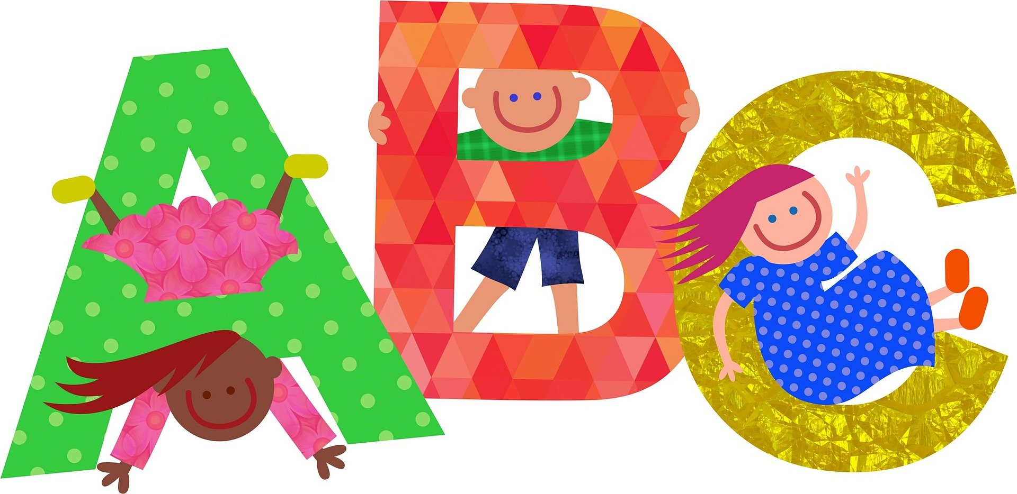

**Alphabet of Authors**

How many authors can you think of?

| A is for... |  | N is for... |  |
| --- | --- | --- | --- |
| B is for... |  | O is for... |  |
| C is for... |  | P is for... |  |
| D is for... |  | Q is for... |  |
| E is for... |  | R is for... |  |
| F is for... |  | S is for... |  |
| G is for... |  | T is for... |  |
| H is for... |  | U is for... |  |
| I is for... |  | V is for... |  |
| J is for... |  | W is for... |  |
| K is for... |  | X is for... |  |
| L is for... |  | Y is for... |  |
| M is for... |  | Z is for... |  |